School of Electronic Engineering and Computer Science
Queen Mary University of London

FINAL YEAR PROJECT DEFINTION
2020-21

This project definition must be undertaken in consultation with your supervisor. The feasibility of the project should have been assessed and the project aims should be clearly defined.
Submission of this document implies that you have discussed the specification with your supervisor.
Project Title: ArtNote
Supervisor: George Fazekas
Student name: Duy Huu Nguyen
Student e-mail: bt17723@qmul.ac.uk
Student phone number: +44 7400 254384

PROJECT AIMS:
State the design, development or research challenge (problem) that the project aims to solve.
Design:
The project is a web application and a platform for artists to sell/share their gallery of artworks while providing inspiration for its users by.In addition,the application will monitor the mood of the users/posts and send suitable posts to users.Furthermore ,it will also,using an api, play music based on user’ s mood and allow user to host art challenges to keep artist’s motivated and relieve stress from long hour of working.
Problem:
Nowadays, social media has become more and more accessible,it’s a platform for user to interact with each other and share their stories.In addition,its also a place for various user’ groups to advertise their brands and products,which in terms of business perspective is a great way for self promotion,one of the groups is artist.However,i believe there are several problems that artists on social media have to overcome.Firstly,artists ,who are new on a social media platform, are likely to have a small chance of being recognized.Secondly,one of the main problem with artists is that they have to work constantly for a long period of time without resting,this could lead to stress and eventually cause art block.Lastly,most platform that allows artists to sell their products tends to be very competitive,especially for new artists on the platform.I believe these problems can be crucial disadvantages because they might keep new artists from advertising and selling their works on-line,restrict freedom in creativity which is important for artistic development and drain inspiration from artists.

PROJECT OBJECTIVES:
List a series of objectives you need to achieve in order to fulfil the aims of your project.

- Research on similar products and evaluate the pro an cons
- Do literature survey on work relate to visual/audio on impact on mood , art impact on stress relief.
- Derive from the research the methods,algorithms and techniques need to be applied to and what can be improved on the project based on other similar projects.
- Evaluate on tool,language ,framework to use for implementation
- Evaluate on which DBMS to use for implementation

METHODOLOGY:
Describe the various steps that you intend to follow in order for you to achieve your project aims.

- Build skeleton for the front-end using dummy data
- Implement main functionalities for the front-end and test
- Create entity diagram,derive models and create database
- Build back-end functionalities and link to database
- Create low-fidelity prototype mainly focusing on the functionality
- Test prototype and iterate until all requirements checked.

PROJECT MILESTONES
Indicate what measurable/tangible components you will produce as part of this project. This may take the form of deliverable document(s) or developmental milestones such as a working piece of software/hardware.

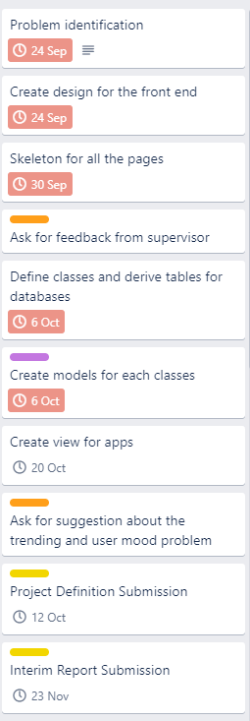
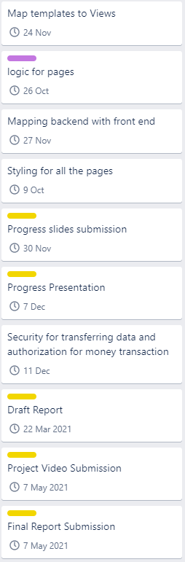

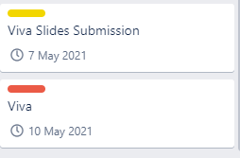

REQUIRED KNOWLEDGE/ SKILLS/TOOLS/RESOURCES:
Indicate as far as possible the skills that are required for you to undertake this project. Also include any software, hardware or other tools or resources that you believe you will need.

Software:
Editor:
- Visual studio code
- Pip as package manager
- Conda for setting up virtual enviroment
Language:
- Javascript
- Python
- CSS
Framework:
- ReactJs
- Django
Database:
- Mysql server
- Mysql workbench
Skills:
- Understand basic of Reactjs, using and importing packages
- Understand basic of Django,Django channel
- Setting up Mysql server and database
TIMEPLAN
This can be a GANTT chart submitted with this document or a list of tasks, milestones and deliverables with timings.

https://trello.com/b/E3RKF9Vs/artnote

